Mrs.M.Parvathi, AP/ECE

N.S.N College of Engineering and Technology

Ms.N.Priya,

UG Student/ECE

N.S.N College of Engineering and Technology

Ms.K.Sangeetha,

UG Student/ECE

N.S.N College of Engineering and Technology

Automatic Spectrum Sharing Technique using Cognitive Radio Network for Efficient Mobile Communication

***Abstract*-** **Energy efficiency problem gains more and more attention these years. Many methods are found out to improve the energy efficiency. However, there are some limitations with these methods. In this paper, to build a system model that jointly considering the sensing tradeoffs and wait tradeoffs and the constraints on the reliability of sensing, the throughput and the delay of SU transmission. The optimal value of sensing time and the probability of the SU waiting in the current channel are found out to make the energy consumption of one data packet transmission minimized. Also, two energy proficiency technologies in spectrum sensing are presented. The spectral-energy proficiency trade-off for CR networks is analyzed at both link and system levels beside fluctuating signal-to-noise ratio values. At the link level, investigate the required energy to achieve a specific spectral efficiency for a CR channel under two different types of power constraint in different fading environments. In this feature, also the transmit power constraint, interference control at the primary receiver is also measured to keep the PR from a destructive interference.At the system level, we study the spectral and energy efficiency for a CR network that shares the spectrum with an interior network. And also to implement the microcontroller based RF module resource sharing successfully implemented.**

***Index Terms*– CR Networks, Spectral –energy efficiency trade off, Signal to Noise Ratio**

# **INTRODUCTION**

Wireless communication is among technology’s biggest contributions to mankind. Wireless communication as thousands or even millions of kilometers for deep-space radio communications. It encompasses various types of fixed, mobile, and portable applications.Some of the devices used for wireless communication are cordless telephones, mobiles, GPS units, wireless computer Wireless communication is the [transfer of information](http://en.wikipedia.org/wiki/Telecommunication) between two or more facts that are not linked by an electrical conductor. The most common

wireless technologies use [radio](http://en.wikipedia.org/wiki/Radio). With radio waves distances can be short, such as a few meters for television or as far. The assumption that some cells in the access network can be switched off when traffic is low implies that radio coverage and service provisioning can be taken care of by the cells that remain active, which requires a, possibly small, increase in the emitted power, and some adjustment in other network parameters, such as antenna tilting; moreover, some switch-off patterns result unfeasible due to specific site positioning that require some cells to be always on to provide full coverage. Main Objective is to reduce the energy consumption in base stations and reduce the amount of CO2 emission. To keep controlling system in every base station for switching purpose. To have complete control over base station to prefer to use PC. In this technology, the mobile communication tower in an area is turned ON, based on the frequency of users present in that area. In general, within a pre-defined control area, there will be multiple towers operating. And each tower has predefined user-strength capacity, up to which it can operate. Thus, based on the user strength in a region, the number of towers in that particular region is turned ON and remaining towers are kept in IDLE state.

Ms.P.Sangeetha,

UG Student/ECE

N.S.N College of Engineering and Technology

# **LITERATURE SURVEY**

The literature [1] heterogeneity refers to the dynamic network conditions in the access point (AP) due to both

Traffic and wireless channel variations. The first technique is a measurement-based predictive approach, known as predictive load balancing (PLB), commonly employed in the network-distributed RRM framework. The second technique is a model-based predictive approach, known as predictive QoS balancing (PQB), typically implemented in the network-centralized RRM framework. The literature [2]The solution of the problem is to find an optimal distribution of radio resources to the RAUs so that a They proposed a solution based on integer programming formulation for the user-centric resource allocation problem. The network considered consists of several Remote Antenna Units connected by optical links to a Base Station Controller at which there are limited number of radio equipment’s (Base Stations) minimum number of BSs are used, decreasing operational costs and deploying energy-efficient wireless network .The literature[3] These techniques are essential for effective network planning, however most of recent RRM algorithms perform static decisions and do not consider users’ positioning, which can lead to resource waste in such dynamic environment. The optimal solutions represent the best compromise that can be achieved between network cost and revenue increase. The approximated algorithm can be implemented when fast solution is required. The proposed model arranges cells in a multi-tier fashion with increasing coverage radius. The literature [4] hence, mobile operators find meeting these new demands in wireless cellular networks inevitable, while they have to keep their costs minimum. They provide a brief survey on some of the work that has already been done to achieve power efficiency in cellular networks, discuss some research issues and challenges and suggest some techniques to enable an energy efficient or “green” cellular network. The literature [5] the cellular network operators feel an impetus towards reducing the energy consumption of their networks in order to decrease the expense of operating a network. The literature [6] energy efficiency has traditionally been an issue tackled by hardware designers and equipment manufacturers. The first area of networking that paid attention to energy consumption was represented by sensor networks, where the peculiarity of the network nodes made energy quite a significant element of the network design space. The literature [7] the Green Radio program sets the aspiration of achieving a hundredfold reduction in power consumption over current designs for wireless communication networks. This challenge is rendered nontrivial by the requirement to achieve this reduction without significantly compromising the quality of service (QoS) experienced by the network’s users. The Green Radio project is pursuing energy reduction from two different perspectives. The literature [8] The network operators are concerned about the cost of power consumption due to the operation of many BSs. There have been many papers that propose energy saving scheme by turning off the BS when traffic level is low. A reference system we consider a BS power-off energy saving scheme which has a simple policy that turns off the BS whenever the traffic of the BS is inactive. This policy is the basic concept of all the conventional papers.The literature [9] modern wireless communication systems have evolved to support increasing numbers of subscribers and provide higher data rate services within the limited frequency resources. As part of this evolution, many transmitted signals in the new standards, such as WCDMA, long term evolution (LTE), and worldwide interoperability for microwave access (WiMAX), now utilize a high peak-to-average power ratio (PAPR) caused by complex modulation schemes, generating the rapid change in the magnitude of signal. The literature [10] Cooperative spectrum sensing improves the reliabilityof detection. However, if the secondary users are selfish,they may not collaborate for sensing. In order to addressthis problem, Medium Access Control (MAC) protocols canbe designed to enforce

cooperation among secondary users forspectrum sensing. In this paper, we investigate this problemusing game theoretical framework.

**BLOCK DIAGRAM**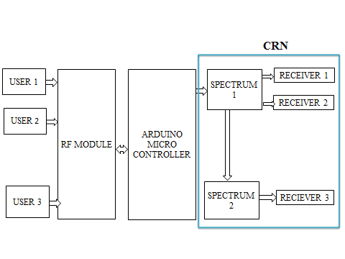 Fig. 1. Block diagram

# **METHODOLOGY**

The mutual nature of the wireless channel requires the synchronization of transmission efforts between CR users. In this esteem, spectrum sharing should include overflowing of the functionality of a MAC protocol. Additionally, the unique characteristics of CRs, such as the cohabitation of CR users with licensed users and the wide range of available spectrum, incur significantly different challenges for spectrum sharing in CR networks. The surviving work in spectrum sharing intentions to address these challenges and can be classified by four features: the architecture, spectrum allocation behavior, spectrum access technique, and scope. The first classification is based on the architecture, which can be centralized or distributed:

• Unified spectrum sharing: The spectrum allocation and access procedures are controlled by a central unit. Moreover, a extent sensing procedure can be used such that measurements of the spectrum allocation are promoted to the central unit, and a spectrum allocation map is constructed. Additionally, the central unit can lease spectrum to users in a limited topographical region for a specific amount of time. Along with struggle for the spectrum, competition for users can also be considered through a central spectrum policy server.

• Scattered spectrum sharing: Spectrum allocation and access are based on local strategies that are performed by each node distributive. Distributed solutions also are used between different networks such that a base station (BS) contends with its interferer BSs according to the QoS requirements of its users to allocate a portion of the spectrum.

The recent work on evaluation of centralized and distributed solutions reveals that distributed solutions generally closely follow the centralized solutions, but at the cost of message connections between nodes. The second grouping is based on distribution performance, where spectrum access can be cooperative or no cooperative.

• Collobarative spectrum sharing: collaborative solutions exploit the interference measurements of each node such that the effect of the communication of one node n other nodes is considered. A mutual technique used in these systems is forming clusters to share interference information locally. This restricted operation provides an effective balance between a fully centralized and a distributed scheme.

• Non-collobarative spectrum sharing: Only a single node is considered in non-cooperative or non-collaborative solutions. Since intrusion in other CR nodes is not considered, non-cooperative solutions may result in reduced spectrum utilization. However, these solutions do not require frequent message contacts between neighbors as in cooperative solutions.

Cooperative approaches generally outpace no cooperative approaches, as well as closely approximating the global optimum. Moreover, cooperative techniques result in a certain degree of fairness, as well as improved throughput. On the other hand, the performance degradation of non-cooperative approaches are generally offset by the significantly low information exchange and hence, energy consumption. The third taxonomy for spectrum sharing in CR networks is based on the access technology:

• Overlay spectrum sharing: Nodes access the network using a portion of the spectrum that has not been used by licensed users. This minimizes intrusion to the primary network.

• Triggered spectrum sharing: The spread spectrum techniques are exploited such that the transmission of a CR node is observed as noise by approved users. Triggered techniques can utilize higher bandwidth at the cost of a minor increase in complication. Allowing for this trade-off, mixture techniques can be measured for the spectrum access technology for CR networks. Finally, spectrum sharing techniques are usually focused on two types of solutions: spectrum sharing inside a CR network (intranet work spectrum sharing) and among multiple simultaneous CR networks (internetwork spectrum sharing), as explained in the following:

• Intranet work spectrum sharing: These resolutions cares on spectrum allocation between the entities of a CR network. Afterwards, the users of a CR network try to access the manageable spectrum without causing interference to the primary users. Intranet work spectrum sharing poses unique trials that have not been considered previously in wireless communication systems.

• Internetwork spectrum sharing: The CR architecture enables multiple systems to be organized in overlying locations and spectrum. So far the internetwork spectrum sharing descriptions provide a broader view of the spectrum sharing perception by together with certain operator policies. Next, we describe the potential challenges and open exploration issues of this phase.

**SOFTWARE DISCRIPTION**

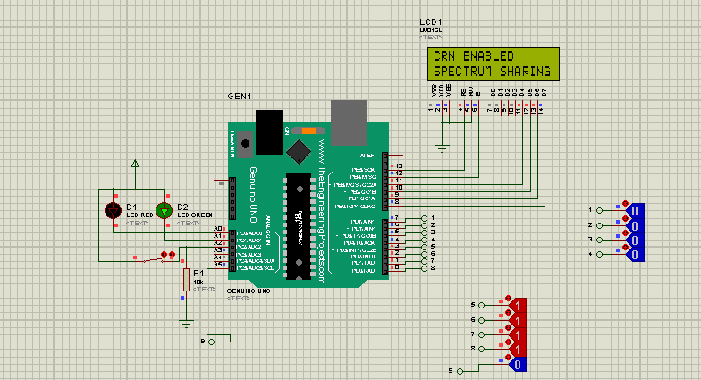

Proteous 17.2

**HARDWARE DISCRIPTION**

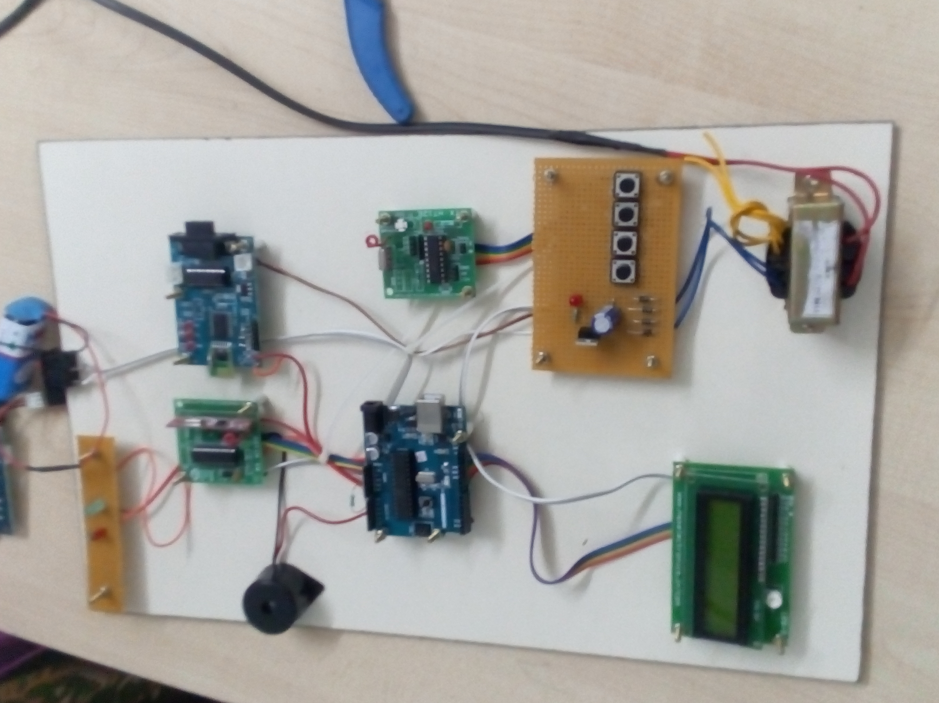

**A) RF Module**

### In normally, the wireless schemes designer has two superseding constraints: it must function over a convinced distance and handover a assured amount of information within a data rate. The RF modules are very lesser in dimension and have a varied operating voltage range i.e. 3V to 12V.

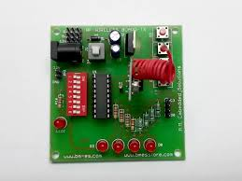

**B) AT mega Microcontroller**

A microcontroller often serves as the “brain” of our system. Similar a mini, independent computer, it can be programmed to interact with both the hardware of the system and the user. Even the maximum basic microcontroller can complete simple math operations, control digital outputs, and screen digital inputs. As the computer business has progressed, so has the technology associated with microcontrollers. Newer microcontrollers are much faster, have more memory, and have a host of input and output structures that dwarf the ability of earlier models. Most up-to-date controllers have analog-to-digital converters, high-speed timers and counters, interpose capabilities, outputs that can be pulse-width modulated, serial communication ports

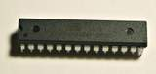

**C) TRANSFORMER**

The probable transformer will step down the power supply voltage (0-230V) to (0-6V) level. Then the secondary of the potential transformer will be connected to the precision rectifier, which is created with the help of op–amp. The advantages of using precision rectifier are it will give peak voltage output as DC; rest of the circuits will give only RMS output.

**D) BRIDGE RECTIFIER**

The input to the circuit is applied to the diagonally opposite corners of the network, and the output is taken from the remaining two corners. Let us assume that the transformer is working properly and there is a positive potential, at point A and a negative potential at point B. the positive potential at point A will forward bias D3 and reverse bias D4

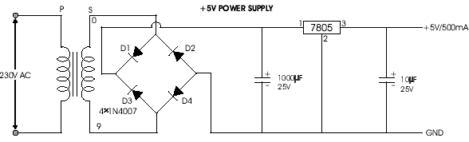

**E)** **LCD:**

A **liquid crystal display** (**LCD**) is a [smooth panel display](http://en.wikipedia.org/wiki/Flat_panel_display), [electronic pictorial display](http://en.wikipedia.org/wiki/Electronic_visual_display), or [video display](http://en.wikipedia.org/wiki/Video_display) that uses the light moderating properties of [liquid crystals](http://en.wikipedia.org/wiki/Liquid_Crystals). Liquid crystals do not produce light directly. LCDs are accessible to display arbitrary images fixed images which can be displayed or concealed, such as preset words, digits, and [7-segment](http://en.wikipedia.org/wiki/7-segment) displays as in a [digital clock](http://en.wikipedia.org/wiki/Digital_clock). They use the same basic technology, excluding that subjective images are made up of a large number of small [pixels](http://en.wikipedia.org/wiki/Pixel), while other displays have larger elements.

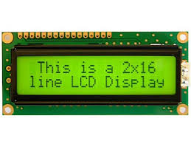

LCDs is used to display the output of the project .In a wide range of applications including [computer monitors](http://en.wikipedia.org/wiki/Computer_monitor), [televisions](http://en.wikipedia.org/wiki/Television), [instrument panels](http://en.wikipedia.org/wiki/Instrument_panel), [aircraft cockpit displays](http://en.wikipedia.org/wiki/Flight_instruments), and signage.

**F) ZIGBEE**:

**Zigbee**  is an [IEEE 802.15.4](https://en.wikipedia.org/wiki/IEEE_802.15.4)-based [specification](https://en.wikipedia.org/wiki/Specification_(technical_standard)) for a suite of complex communication protocols used to create [personal area networks](https://en.wikipedia.org/wiki/Personal_area_network) with minor, low-power [digital radios](https://en.wikipedia.org/wiki/Digital_radio), such as for home computerization, medical device data collection, and other low-power low-bandwidth needs, designed for small scale projects which need wireless connection. Hence, Zigbee is a low-power, low data rate, and close propinquity [wireless ad hoc network](https://en.wikipedia.org/wiki/Wireless_ad_hoc_network).

Zigbee devices can transmit data over long distances by passing data through a [mesh network](https://en.wikipedia.org/wiki/Mesh_networking) of intermediate devices to reach more distant ones. Zigbee is typically used in low data rate applications that require long freestyle life and secure networking Zigbee has a defined rate of 250 kbit/s, best suited for recurrent data transmissions from a sensor or input device.

**IV)ADVANTAGES**:

* When the primary spectrum will overloaded

the call will be automatically connected to

another free spectrum.

* It improve the energy and spectral efficiency.
* It is used to avoid the interference.

**V)CONCLUSION**:

Green energy powered cognitive radio (CR) network is skilled of rescuing the wireless access networks from spectral and energy constrictions. The limitation of the spectrum is improved by exploiting cognitive networking in which wireless nodes sense and utilize the replacement spectrum for data communications, while addiction on the traditional unmaintainable energy is moderated by adopting energy harvesting (EH) through which green energy can be attached to power wireless networks. Green energy powered CR increases the network accessibility and thus extends developing network applications. Scheming green CR networks is challenging. It requires not only the optimization of dynamic spectrum access but also the optimal application of green energy. This paper assessments the energy efficient cognitive radio techniques and the optimization of green energy powered wireless networks. Surviving works on energy attentive spectrum sensing, management, and sharing are investigated in detail. The state of the art of the energy efficient CR based wireless access network is conversed in numerous aspects such as relay and cooperative radio.

**REFERENCES**

### “Spectrum Assignment in Cognitive Radio Networks: A Comprehensive Survey” Elias Z. Tragos, Sherali Zeadally, Alexandros G. Fragkiadakis and Vasilios A. Siris [Communications Surveys & Tutorials, IEEE](http://ieeexplore.ieee.org/xpl/RecentIssue.jsp?punumber=9739) (Volume:15 ,  [Issue: 3](http://ieeexplore.ieee.org/xpl/tocresult.jsp?isnumber=6572931)) July 2013

### “Routing Metrics of Cognitive Radio Networks: A Survey” Moustafa Youssef, Mohamed Ibrahim, Mohamed Abdelatif, Lin Chen, and Athanasios V. Vasilakos [Communications Surveys & Tutorials, IEEE](http://ieeexplore.ieee.org/xpl/RecentIssue.jsp?punumber=9739) (Volume:16 ,  [Issue: 1](http://ieeexplore.ieee.org/xpl/tocresult.jsp?isnumber=6734841)**)**

1. “Spectrum-Map-Empowered Opportunistic Routing for Cognitive Radio Ad Hoc Networks” Shih-Chun Lin, Student Member, IEEE, and Kwang-Cheng Chen, Fellow, IEEE IEEE TRANSACTIONS ON VEHICULAR TECHNOLOGY, VOL. 63, NO. 6, JULY 2014
2. “Closed-Form Analysis of Relay-Based Cognitive Radio Networks Over Nakagami-m Fading Channels” Sattar Hussain, Student Member, IEEE, and Xavier N. Fernando, SeniorMember, IEEE IEEE TRANSACTIONS ON VEHICULAR TECHNOLOGY, VOL. 63, NO. 3, MARCH 2014
3. “Spectrum Bonding and Aggregation With Guard-band Awareness in Cognitive Radio Networks” [Mobile Computing, IEEE Transactions on](http://ieeexplore.ieee.org/xpl/RecentIssue.jsp?punumber=7755) (Volume:13 ,  [Issue: 3](http://ieeexplore.ieee.org/xpl/tocresult.jsp?isnumber=6731368)) MARCH 2014
4. “Efficient Broadcast on Fragmented Spectrum in Cognitive Radio Networks”, [Pei Huang](http://ieeexplore.ieee.org/search/searchresult.jsp?searchWithin=%22Authors%22:.QT.Pei%20Huang.QT.&newsearch=true) ; Dept. of Comput. Sci. & Eng., Michigan State Univ., East Lansing, MI, USA ; [Chin-Jung Liu](http://ieeexplore.ieee.org/search/searchresult.jsp?searchWithin=%22Authors%22:.QT.Chin-Jung%20Liu.QT.&newsearch=true) ; [Xi Yang](http://ieeexplore.ieee.org/search/searchresult.jsp?searchWithin=%22Authors%22:.QT.Xi%20Yang.QT.&newsearch=true) ; [Li Xiao](http://ieeexplore.ieee.org/search/searchresult.jsp?searchWithin=%22Authors%22:.QT.Li%20Xiao.QT.&newsearch=true)
5. “Cognitive Network Interference” Alberto Rabbachin, Member, IEEE, Tony Q.S. Quek, Member, IEEE, Hyundong Shin, Member, IEEE, and Moe Z. Win, Fellow, IEEE IEEE JOURNAL ON SELECTED AREAS IN COMMUNICATIONS, VOL. 29, NO. 2, FEBRUARY 2011
6. “Spectrum Decision in Cognitive Radio Networks: A Survey” Moshe Timothy Masonta, Student Member, IEEE, Mjumo Mzyece, Member, IEEE, and Ntsibane Ntlatlapa, Senior Member, IEEE [Communications Surveys & Tutorials, IEEE](http://ieeexplore.ieee.org/xpl/RecentIssue.jsp?punumber=9739) (Volume:15 ,  [Issue: 3](http://ieeexplore.ieee.org/xpl/tocresult.jsp?isnumber=6572931))July 2013.
7. “Optimal Guard-band-aware Channel Assignment with Bonding and Aggregation in Multi-channel Systems” [Uyanik, G.S.](http://ieeexplore.ieee.org/search/searchresult.jsp?searchWithin=%22Authors%22:.QT.Uyanik,%20G.S..QT.&newsearch=true) ; Dept. of Comput. Eng., Istanbul Tech. Univ., Istanbul, Turkey ; [Abdel Rahman, M.J.](http://ieeexplore.ieee.org/search/searchresult.jsp?searchWithin=%22Authors%22:.QT.Abdel%20Rahman,%20M.J..QT.&newsearch=true) ; [Krunz, M.](http://ieeexplore.ieee.org/search/searchresult.jsp?searchWithin=%22Authors%22:.QT.Krunz,%20M..QT.&newsearch=true) Published in: [Global Communications Conference (GLOBECOM), 2013 IEEE](http://ieeexplore.ieee.org/xpl/mostRecentIssue.jsp?punumber=6821297)
8. “Performance Comparison of Routing Protocols for Cognitive Radio Networks” Li Sun, Student Member, IEEE, Wei Zheng, Naveen Rawat, Vikramsinh Sawant, and Dimitrios Koutsonikolas, Member, IEEE IEEE TRANSACTIONS ON MOBILE COMPUTING, VOL. 14, NO. 6, JUNE 2015 1536-1233 _ 2014 IEEE